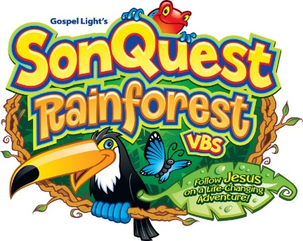
Vacation Bible School Registration Form 2017
June 25-June 29 (Sun.-Thurs.) 4:30-7:30—Ages 3 years to 5th Grade
Immanuel Lutheran Church
830 South Avenue West
Missoula, MT 59801
406-549-0736
Please complete the following information on this confidential form.

Child’s Name

Nickname/preferred name to be called

Parent/Guardian

Address

Home Phone Cell Phone

Home Email Address

Child’s Age Date of Birth Gender: M F

Last school grade completed

Siblings

Home Faith Community (if any)

Over, Please
In case of emergency (when parent/guardian cannot be reached), please contact:

Name

Telephone Relationship to Child

Person(s) responsible for picking up this child at the end of each VBS day:

1. Name Telephone

2. Name Telephone

3. Name Telephone

Please list any allergies/medical needs the VBS staff should be aware of:

Tell us anything special, including special needs/circumstances you would like us to know about your child.

I grant permission for photos/video of my child to be used for promotional/entertainment purposes.

Signature of Parent/Guardian

ONE friend my child would like to be with during VBS
Please indicate below if you would like to volunteer:
Guide Assistant Kitchen Help (meal prep, serving and/or clean up) Other
Days Available

A suggested donation of $25/child or $60/family is asked to help defray costs.
Please consider donating extra to help sponsor a child that may not be able to afford it. Thank you!

